Development Log

Project Setup & Architecture

My objective is to build a structured website (index.html) using semantic HTML5 elements such as <header>, <nav>, <main>, <section>, and <footer>. All styling will be managed via an external stylesheet (style.css).

For this project, I am using VS Code for Web (https://vscode.dev/) as my primary code editor.

The purpose of the website is to present information about me, my interests, projects and contact details in a clear and simple way and the intended audience is my teacher.

I started by creating the basic HTML structure by typing “!” and pressing Tab in VS Code. This created the doctype, html, head and body elements.

<!DOCTYPE html>
<html lang="en">
<head>
<meta charset="UTF-8">
<meta name="viewport" content="width=device-width, initial-scale=1.0">
<title>Document</title>
</head>
<body>

</body>
</html>

I then continued with adding the header, nav, main, section and footer elements to the body
I also added a link in the head section to connect the external CSS file.

Inside my CSS file, I started with the height of #Navigation to 200 pixels, but noticed it was to heigh I changed the height to 50 pixels, which made the page feel more balanced and gave more space to the actual portfolio content.

Early version of the website showing the first navigation structure:
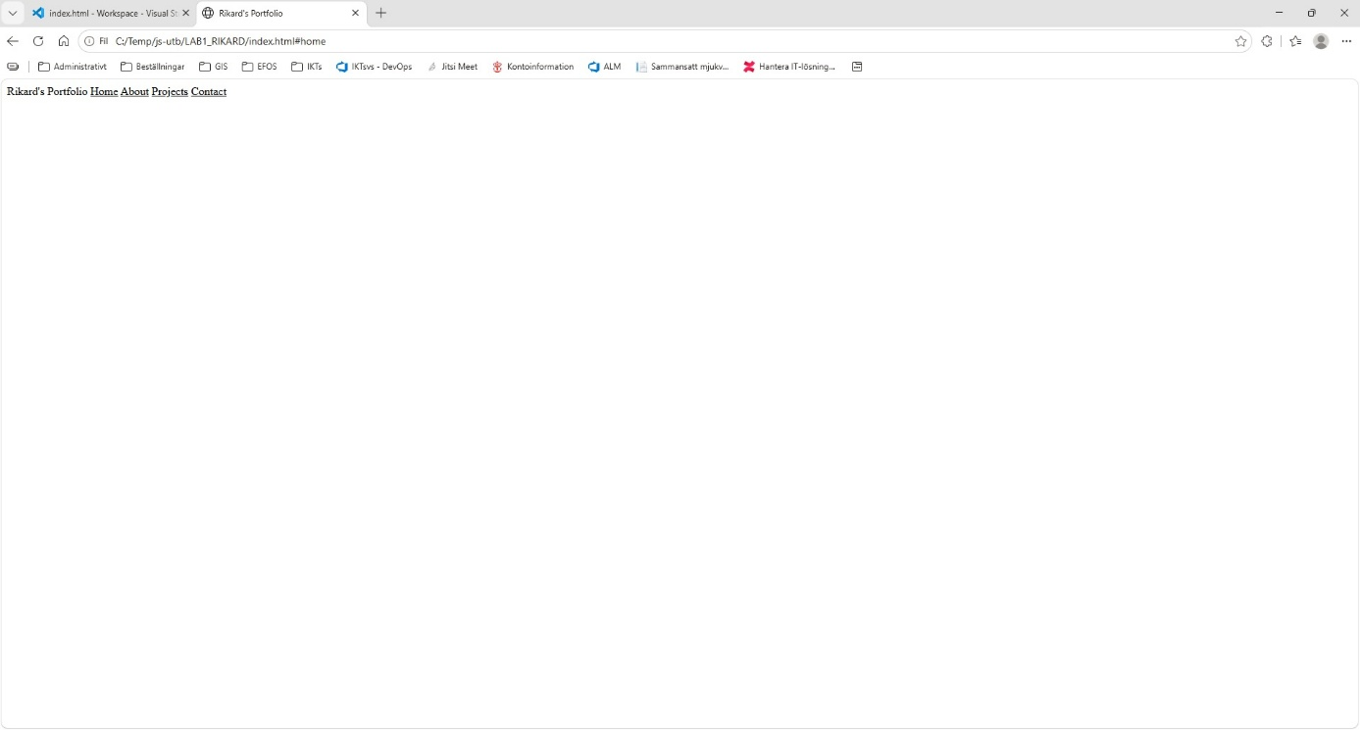

Another change was connected to the sticky navigation. I wanted the navigation to stay at the top while scrolling, but I noticed that it still moved a few pixels. I did not understand why at first, so I searched for an explanation. I found that the browser adds a default margin to the body element. I removed the default spacing with CSS, which allowed the navigation to sit directly at the top of the page. To test the sticky navigation, I temporarily added a large amount of Lorem Ipsum text so that the page became long enough to scroll.

Later, I also centered the main page content and limited its width so that the text did not stretch across the entire browser window. Your current CSS uses a 1000px maximum width with automatic margins for this. I also used my Seed Constraint, #FF6B5E, as an accent color for hover and keyboard-focus states. These changes made the final website clearer, easier to navigate and more consistent than my first version.

Update: my new seed constraint is #C44536 and the CSS-file is now updated.

I finally uploaded the index.html file to my personal domain and tested it on a mobile, it was OK.

